h1{

color: #FF8000;

color: rgba(0, 000, 255, .2);

border: 5px solid purple;

}

outline:

* solid:
* dotted
* dashed
* double /*double outline*/

body{

background:url(https:*//c.pxhere.com/photos/c6/1a/deck_wooden_rain_water_slick_slippery-1261602.jpg!d);*

background-repeat: no-repeat; */*repeat|repeat-x|repeat-y|no-repeat|initial|inherit*/*

background-size: cover;

background-position: center;

background-attachment: fixed; /* Set background image to fixed (don't scroll along with the page

}

.completed{

text-decoration: line-through;*/* underline|overline|line-through|initial|inherit*/*

}

input{

width: 100%;

padding: 13px 13px 13px 20px;

*/*with padding, the input box will overflow the div Container. To avoid:*/*

*/* Specify that <input> elements should have padding and border included in the div's total width and height:*/*

box-sizing: border-box;

}

Specificity:

li{

}

.hello{

}

#name{

}

ul#name{

}

li a{

}

h4 + ul{

}

div#container > ul {

border: 1px solid black;

}

/*X>Y only select direct children*/

ul ~ p {

color: red;

}

/* any p elements, as long as they follow a ul.*/

a[href="http://www.google.com"]{

}

ul:nth-of-type(even){

list-style:

* circle
* square
* upper-roman
* lower-alpha
* none
* square inside url(…….)
* square outside url(…….)

opacity : 0.5

}

div:not(#container) {

color: blue;

}

/* elect all divs, except for the one which has an id of container*/

a:link { color: red; }/* anchors tags which have yet to be clicked on*/

a:visted { color: purple; }

input[type=”radio”]:checked{

}

a:hover{

}

h1{

font-family: Slabo 27px;

font-size: 2.0em;

line-height: 1.5;

padding-left: 40px;

margin: 0 **auto**;

text-transform: uppercase;

letter-spacing: 0.2rem;

box-shadow: 0 0 3px rgba(0, 0, 0, 0.1);

text-shadow: 0px 4px 3px rgba(0, 0, 0, 0.4),

0px 8px 13px rgba(0, 0, 0, 0.1),

0px 18px 23px rgba(0, 0, 0, 0.1);*/* text-shadow: h-shadow v-shadow blur-radius color|none*/*

text-align: center;*/* left|right|center|justify*/*

font-weight: 200;*/* normal|bold|bolder|lighter|number*/*

} <link href="https://fonts.googleapis.com/css?family=Encode+Sans+Condensed|Slabo+27px" rel="stylesheet">

float: left

Advanced float:

**<div** class="clearfix"**>**

**<img** class="img2" src="pineapple.jpg" alt="Pineapple" width="170" height="170"**>**

Lorem ipsum dolor sit amet, consectetur adipiscing elit. Phasellus imperdiet, nulla et dictum interdum...**</div>**

/*To keep the image and the line in same element*/

.clearfix::after {

content: "";

clear: both;

display: table;

}

max-width: 700px;

width: 80%;

transition: all 0.4s

transition: background 0.4s

transition: 0.4s linear

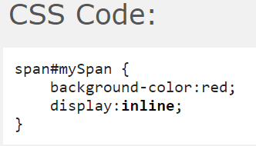

display: inline



display: block

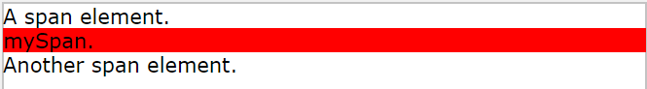

display: inline-block /*The inside of this block is formatted as block-level box, and the element itself is formatted as an inline-level box*/



display: table

